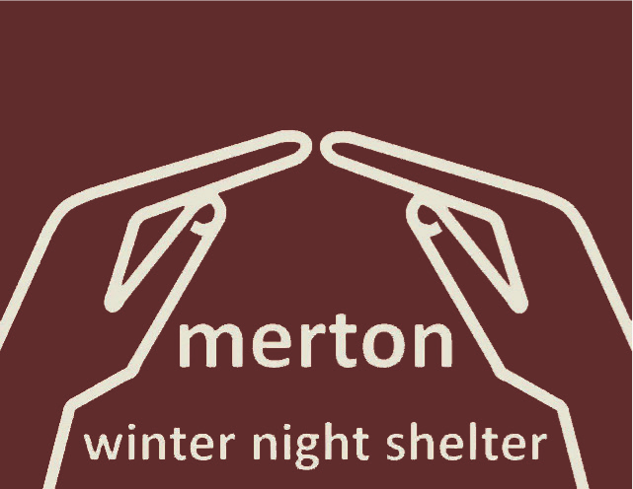

FAITH IN ACTION: MERTON WINTER NIGHT SHELTER: 2022-23 FINAL REPORT

Introduction:

Recent figures released by the Combined Homelessness and Information Network highlighted a 21% increase in people sleeping rough across London between October – December 2022, compared to the same timeframe in 2021. During the same period, there was also a 29% increase in the number of people sleeping rough on London’s streets for the first time.

Living on the streets is both brutal and dangerous; rough sleepers are 17 times more likely to be a victim of physical violence and 15 times more likely to suffer verbal abuse. There is also an increasing number of studies highlighting the correlation between insecure or unsuitable housing and poor physical, mental and financial wellbeing.

Against this background it was with a collective sigh of relief that, under the umbrella of Faith in Action, we were able to bring back together 13 of the Merton Winter Night Shelter (MWNS) venues, their faith groups and volunteer communities to run the communal night shelter for the first winter in three years. Thus, a programme which started in 2012 was restored.

The Night Shelter was able to offer the most essential of services for some of the most vulnerable in our society; a warm welcome, an evening meal and a safe and secure place to sleep during some of the coldest months of the year, with breakfast each morning before guests left for the day.

The absence of government Covid-19 regulations significantly eased the operation of the shelter and allowed us to open a communal facility. However the shelter had a duty of care to both guests and volunteers as Covid-19 was still circulating in the community.

As a result a Covid-19 Response Plan was put in place, by the organisers, in the event of infection with a rolling three-day testing regime for all guests. Volunteers were asked to test at home in advance of their shifts. The shelter had its own isolation unit in the form of a caravan, kindly hosted by St Mary’s Church.

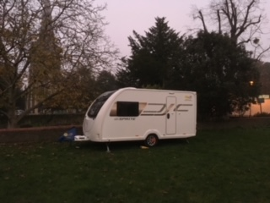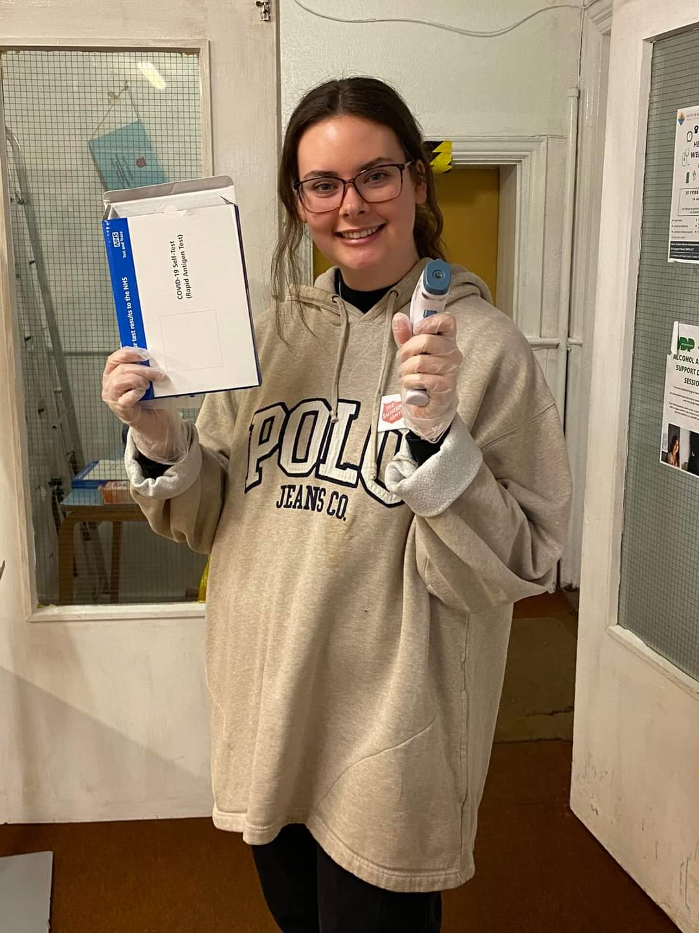

The MWNS Covid-19 Isolation Unit. Volunteer with temperature Gun & Covid Test

The communal night shelter opened on Monday 5th December 2022 at the Wimbledon and District Synagogue and it proved to be just in time. Temperatures in the first week plunged to minus 5C and in the weeks leading up to Christmas went as low as minus 8C in London.
What makes a shelter?
There are so many elements to a successful winter shelter, both tangible and intangible, but all are equally important for our guests.

The Night Shelter:

Our night shelter comprises of:

3 Volunteer Organisers: responsible for the overall running of and fund raising for the shelter.

1 Full time Project Co-ordinator: responsible for communication with all venues, supervision of day-to-day operations and individual casework for our guests.

1 Part-time Project Assistant: responsible for venue support at the weekends and as a Polish speaker, translation services too.

13 Venues: who with their venue co-ordinators organise both the available space and volunteers for the night shelter. Double sessions from St John the Baptist volunteers who covered one night in each block and also the Salvation Army, Wimbledon who provided a venue similarly for one night in each block.

A community of around 360 volunteers.

Support and advice from Faith in Action’s Trustees, Drop In Manager and Treasurer.

The project operated in 2 consecutive blocks of 7 venues opened its doors for the same night each week for 7 weeks, offering up to 11 bed spaces each night.

OUR HOSTING VENUES AND COMMUNITIES

Our teams were also supported by; Wimbledon, New Malden, Korean and Mitcham Salvation Army and volunteer teams from the Quaker community, the Shree Ganapathy Hindu Temple, St James Merton, The Bishop Gilpin Community Choirs, Christ the King, Worcester Park Baptist Church, Roehampton University and the Muslim Women of Merton Group.

Prior to the night shelter start, a choice of 2 volunteer training sessions were offered; in person and online via zoom. Trinity United Reformed Church hosted the first session in a packed central hall. We were delighted to see so many familiar faces along with some new volunteers. Two former managers of the Faith in Action (FiA) Drop In Centre, Ashdon Morgan and Andy Fairbairn lead the sessions. The zoom training session was also well attended.

Volunteers were also offered training sessions in January prior to the start of the 2nd Block.

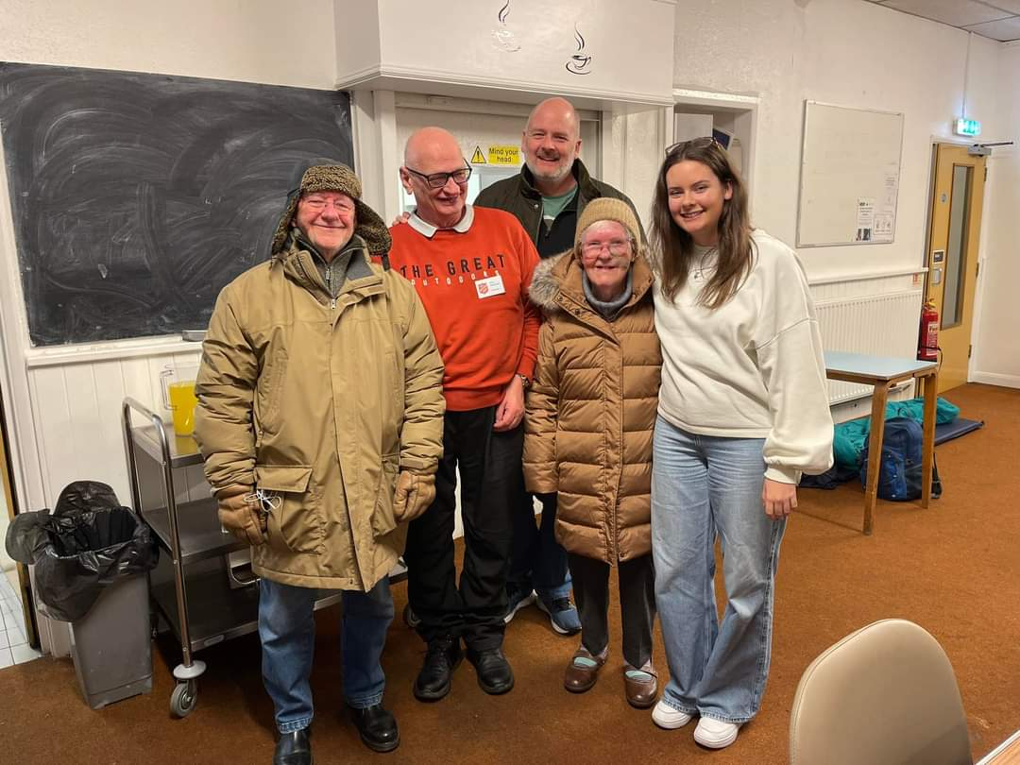

A TYPICAL NIGHT AT THE SHELTER

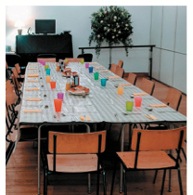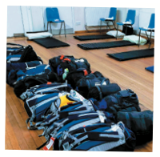

We had a total of 18 different faith communities involved in the Shelter this year with the help of over 360 volunteers. This included preparing and serving delicious meals, transporting the ever growing mountain of luggage, donating time and money to ensure we could open night after night, staying overnight to ensure the safety of all of our guests and turning up week after week to chat with our guests, play games and generally take excellent care of our guests and making them feel welcome and ‘at home’.

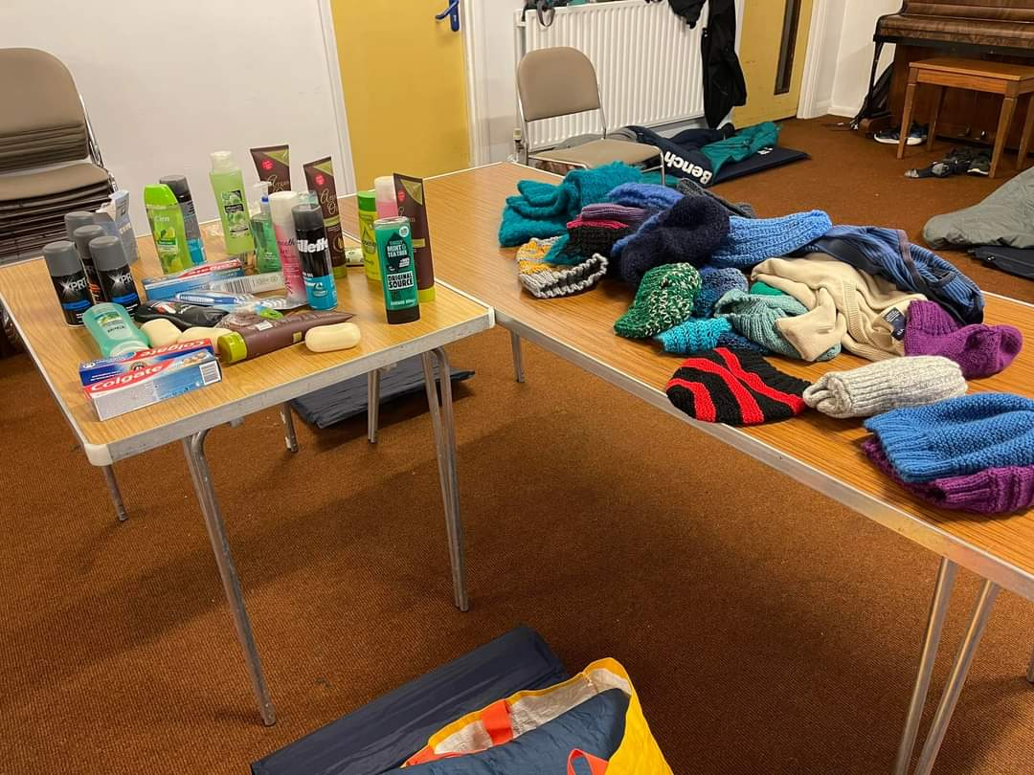
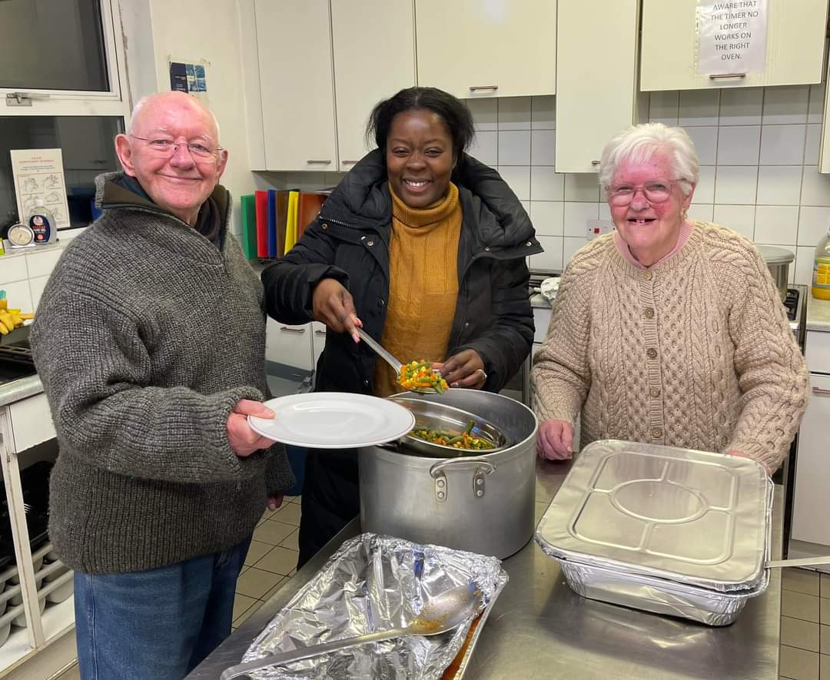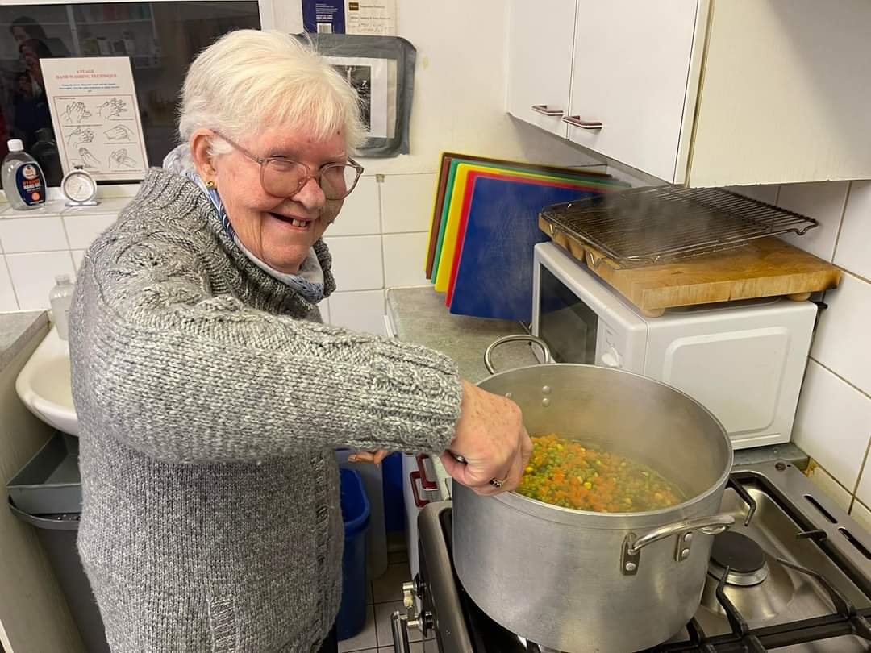

GUESTS

Guest referrals came via the Faith in Action Merton Homelessness Project where the Project Co-ordinator is based twice a week to meet with and assess potential new guests in need of the shelter. Great care is taken in choosing guests because not every rough sleeper can cope with the rules necessary for safe communal living.

Every decision we make is central to the guest’s welfare and general outlook during their stay in the shelter. The moment a guest becomes part of the shelter we immediately start working with them to find out what support they require and work with them to achieve their goals.

We have undertaken 32 guest assessments and 21 guests have taken up offers of a space at the shelter. There was a waiting list running throughout the season for places.

Once a guest is given a place in the shelter they can stay as long as they need, provided they respect the shelter rules. Unfortunately 3 guests lost their places because of this during the course of the shelter this season.

Our guests come from a wide range of working backgrounds and professions including; builders, carpenters, welders, engineers, students and those working in hospitality.

There are many reasons for becoming homeless:

CHRISTMAS AT MWNS

In past years over the Christmas week, all London night shelters have decanted their guests into venues run by CRISIS AT CHRISTMAS. Since 2020 this amenity has no longer operated and this year MWNS ran its own facility over Christmas. Without doing this, the shelter would not have been able to open until 3rd January, i.e., after the Christmas and New Year holidays.

St. Mark’s church hosted on Christmas Eve and Christmas morning. The guests then moved directly to Trinity United Reformed Church, which offered its hall for the next 48 hours until the afternoon of the 27th December, when guests could move on to the Wimbledon Salvation
Army.
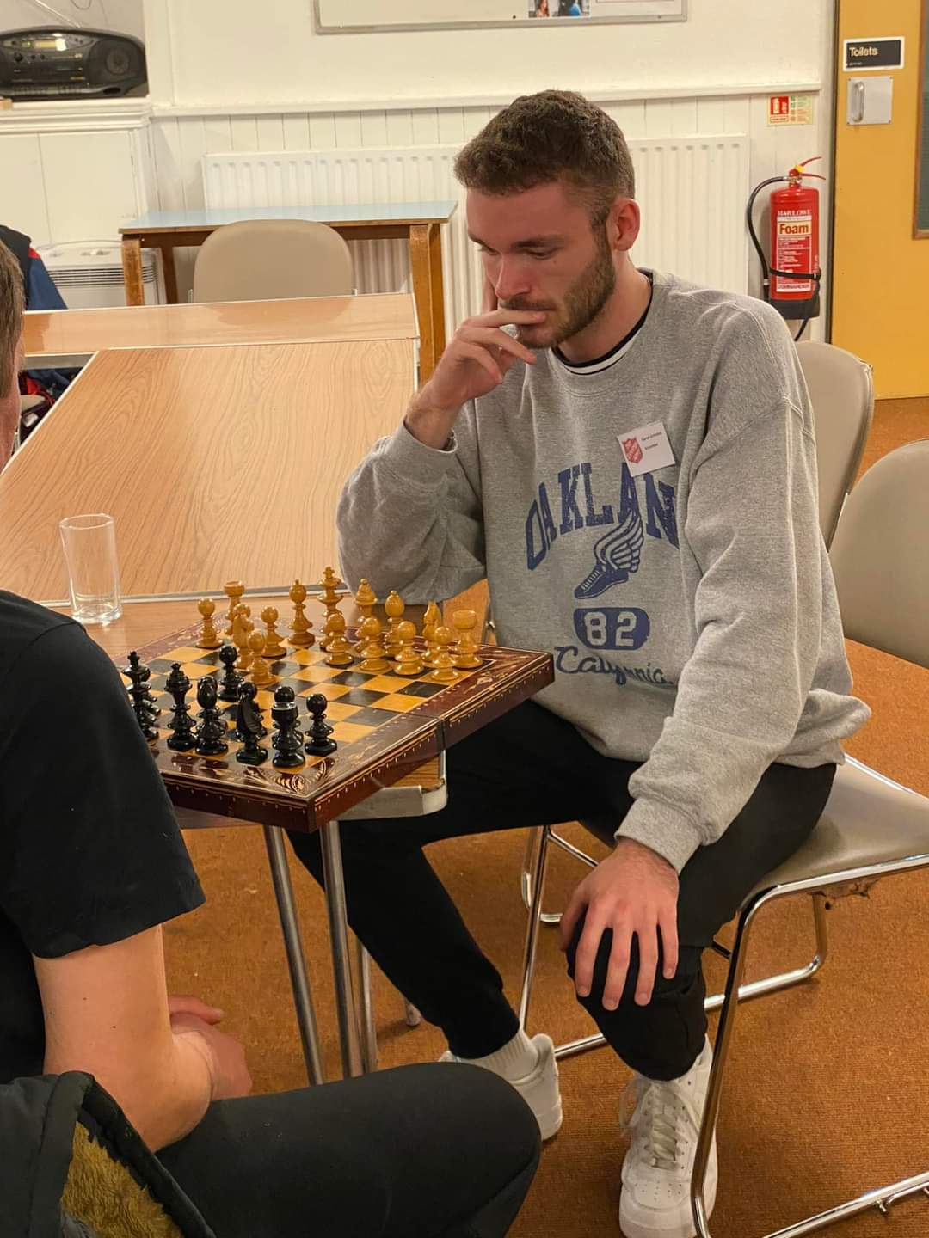
The Wimbledon Mosque cooked Christmas lunch, films were available to watch, fiercely competitive games of table tennis, table football, dominoes and chess were played (one of our guests is a champion chess player), puzzles
were puzzled over and probably most appreciated of all, by our guests, was the ability to lie in bed beyond 6am and to get up whenever they felt like it.

The entire volunteer community was asked for help to provide a 24 hour service to support our guests constantly across the period from Christmas Eve to the morning of 28 December. We are delighted to report that our community very much rose to the challenge, with volunteers from at least 8 different venues doing shifts.

Facts About the Night Shelter:

Our Volunteers included:

- A Professional footballer,
- A local Councillor
- A young gentlemen who completed some volunteer hours by shopping, preparing and cooking a meal for all guests towards his Duke of Edinburgh award
- Theology Students from Roehampton University

This season we enjoyed the return of so many of our wonderful and experienced volunteers so it’s no wonder that the shelter felt like such a well-oiled machine. It was clear that volunteers new and old value the project enormously and thoroughly enjoy being involved. Several people fed back that they felt that they get back far more than they give and love being a part of the shelter community. .
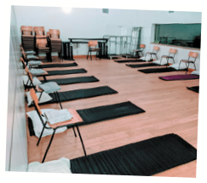

Ian’s Story….
Ian had found himself homeless because of threats of violence towards him by his private landlord and a subsequent physical attack by another tenant, which left him feeling safer sleeping rough rather then continuing to reside in the property.
Ian’s time in the night shelter offered support and allowed him the breathing space he needed to get life back onto an even keel. With the help of the shelter Project Co-ordinator, he was also assisted with his on going Universal Credit claim and with the shelter support was then able to open a bank account.
Ian made the most of his time in the night shelter. Whilst there, he took an IT course through Spear (an outreach charity with whom Faith in Action work on occasion, in support of the homeless) and he has been given a chrome book by them. Ian also applied for his over 60's free bus pass. He was very much looking forward to travelling into central London, something he hadn’t done for a long time.

Ian is now registered at the Nelson Medical Practice and is regularly seeing his GP regarding various health issues. Recently he had a follow up appointment at the doctors. For the first time in over 15 years, he was told he had a clean bill of health. He was so delighted and put this down to the warm, safe environment he has been provided, the healthy three meals a day and the dramatic decrease in his alcohol intake.
With our support and connections with private landlords who specifically work with homeless people and those eligible for housing benefits Ian is now living independently in his own accommodation.

Ian had this to say of his time in the night shelter:

“'All I can say about the Night Shelter is that it is brilliant; lifesaving sounds dramatic but it is the truth. I have been homeless before but when you come to a certain age, the cold, hard, lonely streets was a depressing thought and the relief from that which the Night Shelter provided was so important to me physically and mentally. Having a destination at the end of the day with a delicious hot dinner and seeing the friendly volunteers rather then wandering around the streets aimlessly was so amazing. I am so grateful to every volunteer and everything the Night Shelter did for me.'

Another of our Guests….

Used his time in the night shelter by utilising the safe space to study and gained his Level 3 Bookkeeping qualification and his Level 2 Forklifting qualification. He was subsequently offered a job in a warehouse thanks to his forklifting qualification. The extended night shelter period provided under the Spring Transition Fund allowed him to settle into work and start saving so that by the time the shelter closed on the 9th May 2023, he had found and moved into accommodation near to his work. He hopes to continue with his studies and achieve his goal of becoming an accountant.

SOME OF THE WAYS IN WHICH WE HAVE HELPED

Housing:
- One of our guests was helped in applying for his British passport and to complete his Universal Credit application. As a result, he has now found permanent housing in the Kingston area.

- Two guests who were on the waiting list were able to access housing through Merton Council

- We have supported guests to gain pre settled and settled status. This in turn allows an application for Universal Credit and the prospect of finding more stable housing with our trusted private landlords.

Health:
- Two guests began an alcohol detox programme through Westminster Drug Project.

- One of our guests entered the shelter with a broken arm. The support and stability of the shelter aided in his recovery and he is now actively looking for work.

- One guest was supplied with a pair of glasses.

- One guest was registered to a new GP and after an initial consultation, was put on the correct medication for his various health issues.

Employment:
- One of our guests started work in Fulham as a carpenter for a construction company. He is saving his wages for a deposit and first month’s rent in a room in shared accommodation. He has also started the process to obtain settled status, which will allow him to retain contact with his daughter.

- One of our guests began a new job with a warehouse in Greenford.

- One of our guests returned to work at a local car wash, which included accommodation, after he was let go due to the slump caused by Covid-19.

- Two of our guests found sporadic work as general labours at a construction site in North London area.

Immigration:
- Two guests were referred to St Mungo’s immigration support unit. For one of them (whose papers and identification were stolen) it is the first time in three years he has engaged with the authorities.

- One guest’s solicitor confirmed that they are making an asylum claim on the individual’s behalf and this means that he is eligible for Home Office accommodation and a small amount of financial support.

Together with…..
GP registrations Benefit applications

Liaising with social services Support with opening bank accounts

Housing referrals 60+ Oyster Card application

Grant applications Covering the cost of travel to appointments

Passport applications Mobile phone top ups

Food Vouchers Luggage Transportation and storage

Showers Laundry facilities

And countless emails to councils, housing associations, benefit offices and embassies…….
This season we worked with St Mungo’s, Spear, Bond Dowcra Property, Wimbledon Guild, The Galaxy Café, Wimbledon and Mordon Travelodges, Westminster Drug Project, The Sunshine Recovery Café.

Some of the Challenges:

- Two properties became available and were suitable for a couple of our guests, however most estate agents specify that they will only accept tenants who are over 35 years old as they are entitled to higher Universal Credit payments.

- Another guest who lost his home received legal advice from the NHAS (National Homelessness Advice Service) suggesting that the London borough council’s response (please note NOT Merton) to his loss of home was unlawful and advised a judicial review. During this on going process the guest remains homeless.

- There were a couple of challenging incidents at the shelter this season where guests who breached the shelter rules were evicted and on our first night, the police had to be called to assist the team with the removal of an uninvited guest. The incidents were well managed by those on duty at the time and followed up to ensure all involved were supported. Moreover, the shelter rules will be adjusted to emphasise that guests must not arrive with anyone who does not have an allocated space.

- This season, there were no government Covid regulations to prevent the opening of a communal night shelter. However, it was decided that Covid -19 protocols would be put in place to ensure both guest and volunteer safety. This impacted very much on how many guests we could accommodate this season. Previously, we were able to provide beds for up to 14 people per night and over the course of the night shelter, this allowed us to support up to 30 homeless individuals. This season we reduced space to 11 beds per night, to provide appropriate space between guests, with the inevitable reduction in overall numbers of the homeless we could help.

On Christmas Eve the night shelter organisers received a call from St Mark’s Church, that one of the guests had tested positive. The shelter Covid transport team were on hand to transport the guest to the isolation unit, a caravan sited in St Mary’s Church field. The measures in place helped to reduce the likelihood of transmission and fortunately, this proved to be the only Covid positive case throughout the duration of the shelter.

SPRING TRANSITION FUND 2023:

In March this year an application was submitted to the Mayor of London’s Spring Transition Fund (administered by Housing Justice for the Mayor of London) to cover the cost of hotel accommodation for those guests for whom there was a coherent plan for Move-On.

We were fortunate enough to be awarded a grant of £34,446 and the funding bridged the gap from the closure of the Night Shelter on Monday 13th March up to Tuesday 9th May.

Out of the 9 guests who were at the shelter on our last night, we were able to accommodate 8 guests in hotel accommodation from Monday 13th March up to Tuesday 9th May.

Our Project Co-ordinator worked with our guests during this period, supporting them into new accommodation as it became available. We were delighted that we had the additional time to put into effect a positive outcome for 5 of our guests.

Our Project Co-ordinator continues to work with the remaining shelter guests to support and facilitate their move on requirements through her work at the Faith in Action Drop In Centre. Also our Project Co-ordinator keeps in contact with those who are newly housed in the event that additional support in needed during their settling in period.

MWNS 2022-23 Accounts:

INCOME to 31st March 2023 | Totals |  | EXPENDITURE to 31st March 2023 | Totals
Faith Groups | £21,600 |  | Salaries | £14,635
Trusts | £25,000 |  | Recruitment | £501
Companies | £1,000 |  | WNS masks etc. | £356
Individuals | £4,436 |  | Phones/Rucksacks/Sleeping bags | £979
Gift Aid | £250 |  | Storage with Safestore | £852
 |  |  | Caravan for Isolation Unit | £5,314
 | £52,286 |  | Computer/email | £242
 |  |  | Housing Justice | £395
 |  |  | Audit | £495
 |  |  |  | £23,769
WMNS 2022/23 MAIN BALANCE | £28,517
Spring Transformation Fund
 |  |  | ALL EXPENDITURE (10 March - 31 May 2023)
Grant Income | £34,446 |  | Hotel Accommodation | £34,118
 |  |  | Food & Food Vouchers | £866
 |  |  |  | £34,984
BALANCE | -£538
OVERALL BALANCE TO CARRY FORWARD INTO 2023/24 |  |  |  | £27,979

LOOKING FORWARD

The work of the communal Night Shelter continues for the first time in its history beyond the end of the night shelter through our Project Co-ordinator who is supporting the remaining shelter guests to achieve their goals and to find stable accommodation. We know from the feedback from guests how much they value and appreciate all that is done.

Funding raised this season will allow us to support the Project Co-ordinator post through to the start of the 2023 -24 winter season. In the intervening period contacts with outreach services will be reinforced and consolidated, with further services introduced for the coming season, such as the Green Light Medical Van and hopefully, hairdressing, wider translation services and Emergency First Aid. We will continue to explore how best to help those guests who come into the night shelter.

COLLECTIONS AND DONATIONS

There are some items that instantly help to make our guests feel welcome and other items that are incredibly useful. If you are able to start collecting for next winter, it really does make a difference to our guests.

- Oyster Cards: for guests to travel to and from medical appointments, work, support group attendance. NO negative balances please
- Slippers: The guests have really appreciated being able to slip out of shoes and into slippers. One guest advised us how looking after your feet is essential if you are homeless, there can be so much walking….
- Pyjamas: In previous years we have provided a new pair of PJ’S to guests. This was so popular, we’d like to do it again this winter.
- Mobile Phones: It is critical for us and third parties to be able to easily contact our guests during the hours they are not in the shelter

ACKNOWLEDGEMENTS AND THANK YOUS

We are so very fortunate to have such amazing support from so many brilliant volunteers, faith group communities, services, partners and funders in our community who all help towards the success of the night shelter.

We are extremely grateful to the Faith in Action staff team for assisting with advice, translation and follow up support during the season. An especial thank you to our Assistant Project Co-ordinator, Maria, for her help and assistance at weekends.

We would also like to thank Matt Penn (Peripatetic Housing, Care and Support Specialist) and his team, together with the Reception team from the Wimbledon YMCA St Pauls Group for their support and practical help throughout the season.

FUNDERS AND SUPPORTERS

The Wimbledon Foundation
The Rowlett Trust
Our hosting Faith Group Communities
Abundance Wimbledon
Barre Wimbledon
The Salvation Army South Wimbledon
D & S Tailoring, Wimbledon Park
Housing Justice
London Borough of Merton
Wimbledon YMCA St Paul’s Group
The Wimbledon Guild
The Galaxy Cafe
CDARS

AND all the individuals who have so generously donated to the night shelter, along with the other faith groups, community groups, schools and colleges who contributed in so many different ways. Your support is invaluable and greatly appreciated.

Jane Bush, Robin Goodchild, Talat Malik, (Trustees Faith in Action) Ashling Flannery (Night Shelter Project Co-ordinator)

